 | 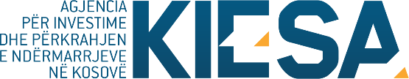

Republika e Kosovës
Republika Kosova-Republic of Kosovo
Qeveria –Vlada-Government
Ministria e Tregtisë dhe Industrisë-Ministarstvo Trgovine i Industrije-Ministry of Trade and Industry

Agjencia për Investime dhe Përkrahjen e Ndërmarrjeve në Kosovë (KIESA)
Agencija za Investicije i Podršku Preduzeča na Kosovu (KIESA)
Kosovo Investment and Enterprise Support Agency (KIESA)

Announcement

Based on the public call for subsidies to projects of entities that contribute to export and promotion of Kosovo tourism potentials, published on 26.07.2017, and based on Administrative Instruction MTI no. 03/2016 on the Allocation of Financial Assets by the Economic Category of Subsidies and Transfers ("AI MTI 03/2016"), the Review Committee has received all applications and has published the preliminary list of beneficiaries and transfers subsidy.

The preliminary list of beneficiaries and transfer subsidy:
:
- Kosovo Chamber of Commerce “KCC”
- Congress& Event Organization “CEO”.

Entities that have applied for and are not included in the list of beneficiaries and transfers subsidies may appeal to the Complaints Review Commission within 15 (fifteen) days after the publication of the preliminary list according to the Administrative Instruction (MTI) no. 03/2016 on the Allocation of Financial Assets from the economic category of subsidies and transfers.

