Republika e Kosovës
Republika Kosova-Republic of Kosovo
Qeveria - Vlada – Government

Ministria e Tregtisë dhe Industrisë - Ministarstvo Trgovine i Industrije - Ministry of Trade and Industry

DEPARTMENT OF INDUSTRY

TOURISM DIVISION

IDENTIFICATION OF TOURISM PRODUCT IN THE REGION OF PRISHTINA
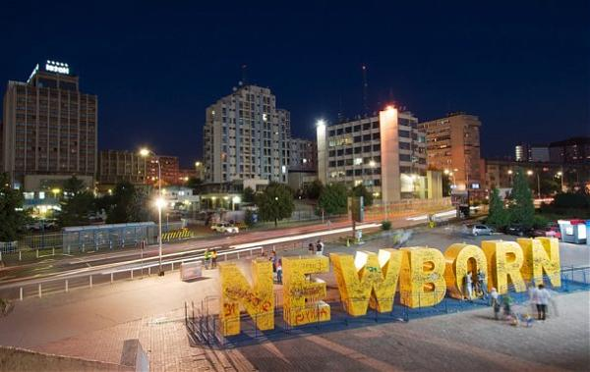

PRISHTINA 2017

Terms of Reference
MTI / TD, Ministry of Trade and Industry / Tourism Division
Local Governance, municipalities that are part of Prishtina Tourist Region
Tourism Coordination Team, Tourism Division staff from (MTI), local staff and business community PTR, Prishtina Tourist Region
Municipality, territorial area of the municipality
Tourist area, tourist areas within the municipality
Touristic locality, locality situated within one or more tourist areas
Tourist infrastructure, legal infrastructure, road and other accompanying infrastructure (water supply, electricity, sewage, telephone, Internet)
Tourism product represents all of the material goods and services, put in service of fulfilling the tourists’ demands, starting from the travel and throughout the time of stay in the touristic destination.
Tourist offer, the amount of tourist goods and services that are placed in the market and which serve to satisfy the tourist demand at a certain price
Tourist demand, is the entirety of tourist goods and services which can be provided to tourists at a certain price
Natural heritage, in its broadest sense, covers not only the fauna and the population of a certain country, protected or not, but also its geological sights and panoramic landscapes
Cultural heritage covers any kind of cultural expression left as a legacy from the past and inherited from today's society
Tourist attractions, cultural and natural heritage values, attractive to tourists
Tourist transport, the entire transport services provided to tourists
Tourist services, services provided to tourists
Package tour, all services provided to tourist, from the departure away from his or her residence to the arrival at the designated tourist destination and return
Touristic tour operators, tourism businesses who prepare and provide package tours
Accommodation facilities, hotel entities that provide accommodation services
Tourist information office, offices where tourists can obtain tourist information
Tourist guide, competent person who informs tourists about certain places, tourist sites, etc.
Tourist chaperon, competent person accompanying tourists
Tourism promotion and marketing, advertising of tourist offers through printed and electronic media, brochures, CDs, films etc., Internet services for tourists (tourism websites, tourist navigators etc., tourist signalling etc.

THE REPUBLIC OF KOSOVO

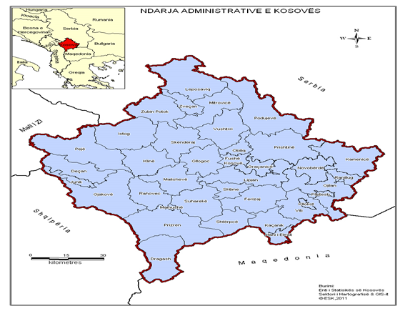
The Republic of Kosovo is situated in Southeast Europe - Time Zone GMT+1. It is located in the centre of the western part of the Balkan Peninsula, and is traversed by important roads connecting this part of the Balkan Peninsula to the Western and Eastern Europe. Kosovo has a geostrategic position at the Centre of the Balkans; Route 7 and 10; and is a connecting node between Europe and Asia. It borders with Serbia, Macedonia, Albania and Montenegro. Territory: 10,908 km², with 1,804,944 inhabitants (2014 estimate) Humid continental climate, average temperature: January - 5 C, and June 24 C, with sufficient precipitations.
Ethnic composition 90 % Albanian, 5 % Serbs, 2 % Bosniaks and Gorani, 2 % Roma, and
1 % Turkish
Diaspora: over 800,000 people abroad Languages: Albanian, Serbian, English Currency: Euro (€) Fig 1. Kosovo Map
GDP per capita (2013) 2,773.00 EURO

TOURISTIC REGIONS OF THE REPUBLIC OF KOSOVO

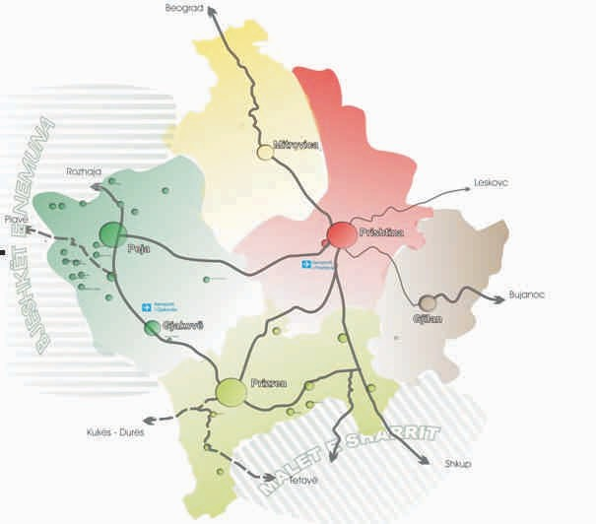
Viewed from the tourism point of view, Kosovo is divided into five touristic regions:

1. The central region of Prishtina;

2. The Albanian Alps tourist region (Bjeshket e Nemuna);

3. Sharri tourist region;

4. Anamorava tourist region;

5. Tourist Region of Mitrovica & Shala e Bajgorës.

Fig. 2. Map of Kosovo’s five tourism regions

The Tourism Division in coordination with other relevant institutions and local government - The Tourism Coordination Team has initiated the identification of the tourism product with the aim of raising the region’s awareness of its significant potentials, future development initiatives and actions, and the commencement of work on developing its tourism product.

The Coordination Team has identified elements of the touristic product, which enabled the identification of projects for developing, designing, promoting and implementing the outcomes of the tourism product, aiming to launch the tourism product in Kosovo and abroad.

PRISHTINA TOURISM REGION
This tourism region covers an area of 2365 km2, with over 500.000 inhabitants. It consists of these municipalities: Prishtina, Podujeva, Obiliq, Fushe Kosove, Drenas, Graçanice, Lipjan and Shtime. Prishtina is the cultural, educational, political, economic and communicative centre of Kosovo.
The table and the chart below show the fluctuations in the number of tourists by regions in Kosovo. If we are to compare the number of visitors for the period 2010-2016 by regions in Kosovo, one will notice that the region of Prishtina leads with the highest number of visitors.

Table 1. Number of (domestic and foreign) visitors by region for the period 2010 - 2016
Regions | 2010 | 2011 | 2012 | 2013 | 2014 | 2015 | 2016
Gjakova | 2031 | 1640 | 1597 | 1517 | 2062 | 2269 | 4373
Gjilan | 1976 | 2251 | 1937 | 1718 | 1552 | 1635 | 2410
Mitrovica | 2894 | 2646 | 2875 | 2915 | 2631 | 2247 | 2445
Peja | 8337 | 6633 | 7593 | 6630 | 11534 | 31707 | 24110
Prizren | 4663 | 5434 | 6212 | 8109 | 8615 | 16316 | 16479
Prishtina | 49172 | 46636 | 68537 | 68687 | 77167 | 89050 | 76543
Ferizaj | 9972 | 7153 | 10012 | 5878 | 4229 | 6216 | 2929

As is noted in the table, the region of Prishtina has the largest number of visitors during 2016 with a total of 76 543 visitors, followed by Peja with 24 110 visitors and Prizren with 16 479 visitors.

Data on Kosovo’s accommodation capacities

Table 2. Data on capacities by categories of accommodation units
Categories of accommodation units | Capacities of
Categories of accommodation units | Units | Rooms | Beds
Hotel | 194 | 4.329 | 7.066
Motel | 182 | 2.170 | 2.916
Guest house | 9 | 39 | 79
Hostel | 9 | 43 | 171
Apartments for visitors | 15 | 25 | 32
Bungalow | 38 | 330 | 721
Camping areas | 17 | - | -
Total active units | 464 | 6.936 | 10.985
Inactive units | 31 | : | -
Total | 495 | 6.936 | 10.985

The table number 2 shows that there are a total of 464 active accommodation units in Kosovo, out of which hotels have the largest share with a total of 194 units, followed by motels with 182 units. Hotels account for the largest number of rooms with 4.329 rooms and 7.066 beds.

Table 3. Basic data on accommodation capacities by municipalities
 | Municipality | Accommodation units |  |  | Camping spaces
 |  | Number of units | Number of rooms | Number of beds | Number of spaces | Number of places
1 | Deçan | 3 | 39 | 56 | - | -
2 | Dragash | 2 | 86 | 180 | - | -
3 | Drenas | 6 | 77 | 77 | - | -
4 | Ferizaj | 41 | 584 | 669 | - | -
5 | Fushe Kosova | 22 | 336 | 381 | - | -
6 | Gjakova | 15 | 254 | 330 | - | -
7 | Gjilan | 22 | 303 | 458 | - | -
8 | Graqanica | 13 | 244 | 305 | - | -
9 | Han i Elezit | 1 | 10 | 12 | - | -
10 | Istog | 13 | 382 | 671 | - | -
11 | Junik | 2 | 10 | 36 | - | -
12 | Kaçanik | 5 | 40 | 42 | - | -
13 | Kamenica | 2 | 17 | 34 | - | -
14 | Klina | 12 | 148 | 237 | 6 | 435
15 | Lipjan | 13 | 150 | 152 | - | -
16 | Malisheva | 4 | 30 | 60 | - | -
17 | Mitrovica | 13 | 248 | 375 | - | -
18 | Novo Brdo | 3 | 25 | 40 | - | -
19 | Obiliq | 7 | 114 | 126 | - | -
20 | Peja | 58 | 760 | 1.533 | 11 | 1.295
21 | Podujea | 4 | 100 | 201 | - | -
22 | Prishtina | 78 | 1.569 | 2.245 | - | -
23 | Prizren | 54 | 808 | 1.702 | - | -
24 | Rahovec | 9 | 82 | 101 | - | -
25 | Ranillug | 1 | 5 | 7 | - | -
26 | Shterpca | 10 | 101 | 251 | - | -
27 | Shtime | 5 | 45 | 47 | - | -
28 | Skenderaj | 3 | 32 | 50 | - | -
29 | Suhareka | 11 | 143 | 279 | - | -
30 | Viti | 6 | 53 | 93 | - | -
31 | Vushtrri | 4 | 74 | 94 | - | -
32 | Zubin Potok | 2 | 20 | 40 | - | -
33 | Zveçan | 3 | 47 | 101 | - | -
 | Total | 447 | 6.936 | 10.985 | 17 | 1.73

Out of a total of 464 active accommodation units, 17 of them are camping areas. Their registered capacity is 6,936 rooms and 10,985 beds. Camping areas are secondary units within the main unit. A total of 17 camping spaces with a capacity for 1,730 persons are registered.

MUNICIPALITY OF PRISHTINA
Prishtina is the Capital City and main centre of the Prishtina Touristic Region. The Municipality of Prishtina has an area of 572 km2, with a population of 198.214 residents, or 347p/km2. Prishtina serves as an intersection and interweaving of national, regional and local roads.
Additionally, the hotel catering service is advancing more and more every-day, whereby currently there are 781 restaurants and hotels in the Municipality of Prishtina.
With regard to tourism, the Municipality of Prishtina may be divided into the following touristic localities:
City’s touristic locality and the touristic locality of Germia Park
The cultural heritage is a special chapter that reflects the antiquity of Prishtina as an administrative and cultural centre, dating back from the old Dardania, 3500 years ago and until today.
The statute of the Queen of Dardania (Goddess on the Throne) is located at the Museum of Prishtina.
Moreover, The Hamam of the City and the House of Emin Gjika, in which the Academy of Sciences and Arts of Kosovo is currently placed, are also located in Prishtina.
Prishtina also has the Central Archive of Prishtina, and the Monuments of Skenderbeu, Zahir, Pajaziti, Mother Theresa, New Born obelisk etc.
Cultural and natural heritage of the Municipality of Prishtina are the National Theatre of Kosovo (NTK), National and University Library of Kosovo, Museum of Kosovo, Gallery of Arts.

Organization in tourism sector
Although the Municipality of Prishtina has a tourism potential, it has not yet assumed its role in developing the touristic products, which would have an impact on the economic development, youth employment, increase of citizens’ living standard and welfare, both in the municipality and beyond.
- Municipality of Prishtina still has no Tourism Development Strategy,
- There are no human capacities for developing tourism at municipal level,
- There is no touristic information office,
- There is no website for touristic information in Prishtina

Accommodation capacities
Based on the most recent data from KAS, the Municipality of Prishtina has 78 accommodation facilities with a capacity of 1569 rooms and 2245 beds.
The Municipality of Prishtina does not have good opportunities for developing tourism compared to other municipalities of Prishtina’s touristic region.
Prishtina’s touristic offer may be oriented towards: the landscapes of Germia Forest, which have a rare natural beauty, and a network of settlements with organised services connected to main traffic routes;
Good opportunities for developing agro-tourism; properties, ethnic and cultural diversity, but also preserved cultural and historical facilities, special monuments, etc.
In terms of touristic development, the Municipality of Prishtina is divided into two touristic areas:
- Touristic locality of Germia,
- Touristic locality of Prishtina and its surroundings,

Rich natural and cultural heritage, primary elements of touristic product
Germia is a Regional Park, proclaimed as a protected area. It has a surface area of 62km². It is characterised by a range of natural beauties and values. An important part of the protected area are the recreational and rest areas such as: pools, sport areas, walking path, restaurants and other resting points. The Germia Park attracts the attention of a large number of people from Prishtina, Kosovo and foreign visitors.
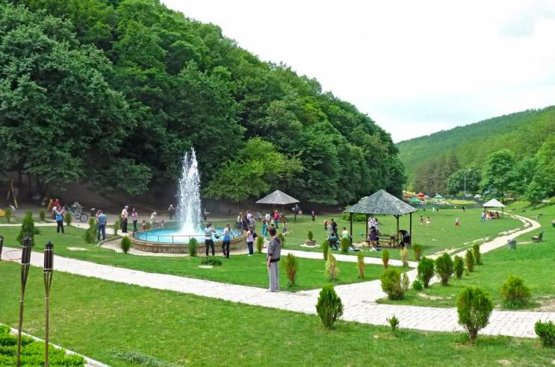
Photo 1. National Recreational Park „Germia“

Touristic locality of Prishtina and its surrounding area – natural heritage
- Planning and regulating the Germia’s touristic centre;
- Planning and regulating the signalling and lighting;
- Development and support of locality’s touristic product;
- Promoting the touristic product.

Touristic locality of Prishtina and its surrounding area – cultural heritage.
- Restoration and valorisation of religious facilities;
- Searching and valorisation of archaeological localities;
- Valorisation of cultural heritage monuments.

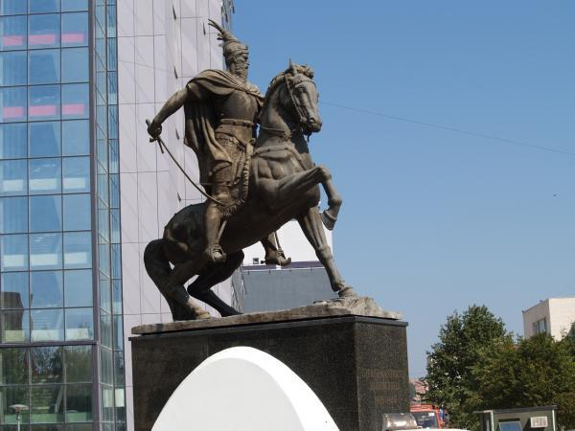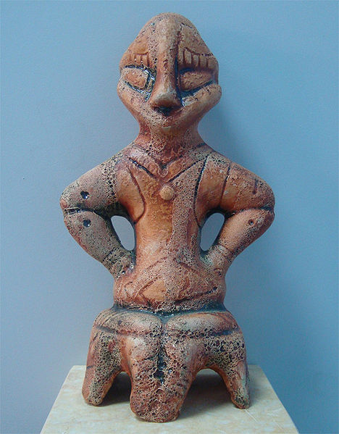
Photo 2. Monument of Gjergj Kastrioti-Skënderbeu“ Photo 3. Goddess on the Throne

This monument is located at the centre of the city, near to the building of the Parliament and the Government of Kosovo. This monument is of special importance and symbolises the national hero of all Albanians in the Balkan’s region.

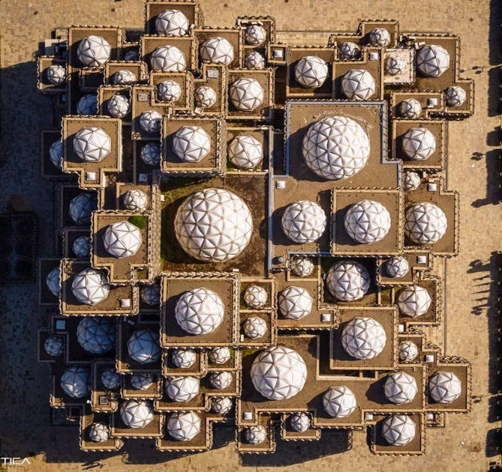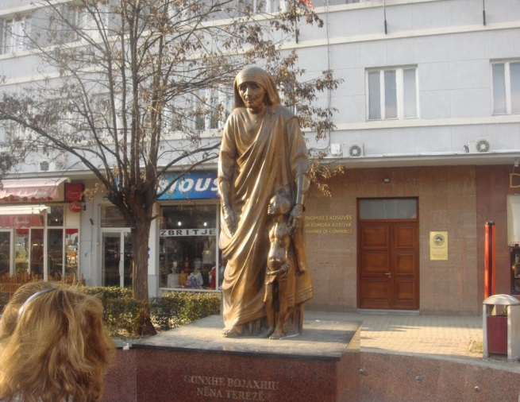
Picture 4. National Library | Picture 5. Mother Teresa 1910-1997

Possible projects for tourism development in the municipality of Prishtina:
1. Design of urban and detailed plans of tourist localities
▪ Touristic locality of Germia Forest,
▪ Touristic locality of Prishtina and its surroundings
2. Organizational and institutional scope of the tourism sector;
3. Completion of the tourist legal infrastructure, under the competence of local government
4. Stimulation of development, protection of craft activities and ethnographic heritage;
5. Support to cultivation of traditional gastronomy
6. Support to development of tourist marketing and promotion at the municipal level;
7. Identification and promotion of marked days, manifestations at the municipal level;
8. Development of tourist signalling project;
9. Establishment of an ethnographic museum;
10. Support to the development of human resources in the tourism sector;
11. Creating facilitation for investment in tourism.

Conclusions and recommendations
In order to develop tourism in the municipality of Prishtina, the following is considered as necessary:
Design of urban and detailed plans of tourist localities:
- Touristic locality of Germia forest - enhancing and expanding the touristic offer with new products such as new walking paths in Germia and surrounding forests, the Zip Line slide in Germia, building an adventure park for children, etc.
- Touristic locality of Batllava Lake - with the aim of creating conditions for: cycling, horseback riding, skating, outdoor excursions, picnics, camping, swimming, fishing, bird watching, etc.,
Establishment and institutional operationalization of the tourism sector,
Completing the local legal infrastructure,
Protecting and encouraging craft and ethnographic activities,
Stimulating the development of traditional foods and specialties,
Developing the promotion of local tourism,
Creating the conditions for development of rural tourism,
Establishing a tourist information office,
Manifestation and promoting specific days,
Development of the Tourism Marking project,
Development and building capacities of human resources in the tourism sector,
Creating facilitations for investment in tourism,
Organizing numerous festivals and fairs that would attract tourists,
Developing and modernizing capacities in providing services for congressional and business tourism,
Developing recreational and sports activities on the city square (e.g. skating),
Virtualization of cultural heritage facilities with software equipment and their networking in order to be offered in a common guide

MUNICIPALITY OF BESIANA (PODUJEVA)
The municipality of Besiana, once the old town of Llapi Province, is transforming into a beautiful city and a centre of economic importance. However, the tourism potentials are located in the surrounding villages
Accommodation capacities
There is a lack of accommodation capacities in this municipality; namely, there are 4 accommodation units with a total of 100 rooms and 201 beds.
Organization in the tourism sector
- Insufficient level of institutional organization in the tourism sector
- There is no tourism development plan or strategy in the municipality of Podujeva,
- There is no tourist information office,
- There is no tourist website,
- There is no tour guide and tourist companion, there is no tourist package arrangement,
- Tourist signalling is not fully regulated.
Batllava locality:
- Realization of the detailed urban plan of Batllava locality;
- Planning and regulation of paths;
- Planning and regulation of signalization and lighting;
- Regulation of necessary infrastructure (water supply, sewage, placement of waste containers), park maintenance;
- Planning and placing benches;
- Organization of cultural-sports activities;
- Development of cross-border tourism projects
- Development of cross-border tourism projects
- Promotion of tourism product:
- Shala e Bajgorës locality:
- Development and support of the locality’s tourist product,
- Promotion of tourism product.
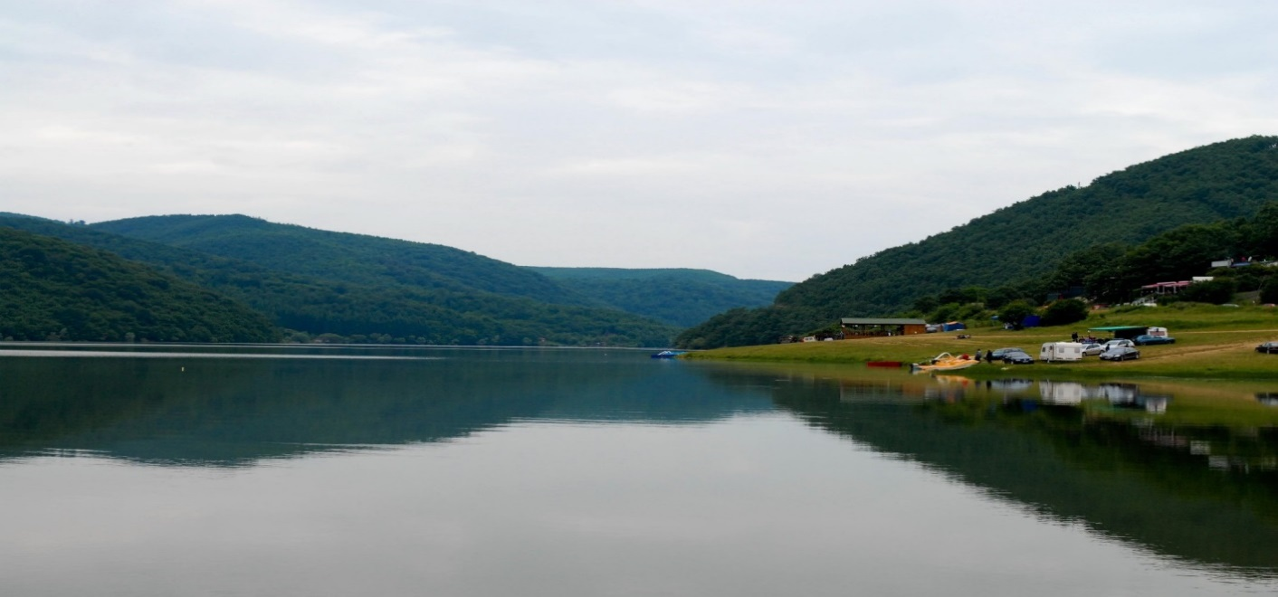
Picture 6: Batllava Lake

Locality of Llap River Source
- Establishment of a tourist centre in the surrounding area of the source;
- Organization of competitive water sports (canoe and kayak, swimming);
- Organization of fishing tournaments;
- Planning and regulation of signalling and lighting;
- Support for development of agro-tourism and rural-tourism;
- Development and support of the locality tourist product
- Promotion of tourism product.

Area of the city of Podujeva and its surrounding - cultural heritage:
- Restoration and valorisation of Towers (Kullave);
- Restoration and valorisation of urban areas;
- Restoration and valorisation of cult facilities;
- Restoration and valorisation of Castles;
- Restoration and valorisation of mills;
- Valorisation of cultural heritage monuments.

Potential projects for tourism development in the municipality of Podujeva:
1. Design of urban and detailed plans of tourist localities
- Batllava locality,
- Shala e Bajgorës locality,
- Locality of Llap River Source,
- Kopaonik locality
- Organization and institutional scope of the tourism sector;
- Completion of the tourist legal infrastructure, under the competence of local government;
- Completion of the tourist legal infrastructure, under the competence of local government:
- Stimulation of development and protection of craft activities;
- Support to the cultivation of traditional gastronomy;
- Support to the development of tourism marketing and promotion of all localities at municipal level;
- Identification and promotion of specific days at municipal level;;
- Development of tourist signalling project;
- Support for development of human resources in the tourism sector;
- Creating facilitation for investment in tourism.

Conclusions and recommendations

In order to develop tourism in the municipality of Prishtina, the following is considered as necessary:
1. The design of a Tourism Plan or Strategy for the municipality of Podujeva,
2. Design of urban and detailed plans of tourist localities:
- Tourist attraction of Shala e Bajgorës - aimed of creating conditions for: outdoor activities, cycling, horse riding, skating, outdoor excursions, picnics and camping, bird watching, botanical garden, etc.
- Tourist attraction of Batllava Lake, with the aim of creating conditions for: outdoor activities, fishing, swimming, cycling, horseback riding, skating, outdoor excursions, picnics, camping, swimming, fishing, bird watching, botanical garden, etc.,
Establishment and institutional operationalization of the tourism sector,
Completing the local legal infrastructure,
Protecting and encouraging craft and ethnographic activities,
Stimulating the development of traditional foods and specialties,
Developing the promotion of local tourism,
Manifestation and promoting specific days,
Development of the Tourism Marking project,
Development and building capacities of human resources in the tourism sector,
Creating facilitations for investment in tourism.

MUNICIPALITY OF GRAÇANICA

The Municipality of Gracanica has the Strategy for Development of Tourism 2016-2021.
The accompanying tourism infrastructure is mainly constructed (roads, water supply, sewage, signalling, telephone, internet. Tourist signalling is under construction. The main roads Prishtina-Gjilan and Prishtina-Skopje pass through the city of Gracanica, along with the new Prishtina-Skopje motorway; the website “Turističke organizacije Gračanica” is functional and has a tour package offer for the municipality of Gracanica.

Tourist attractions:
1. Gracanica Monastery
2. Ulpiana Archaeological Park
3. Church of Sv. Dimitrija
4. Badovc Lake

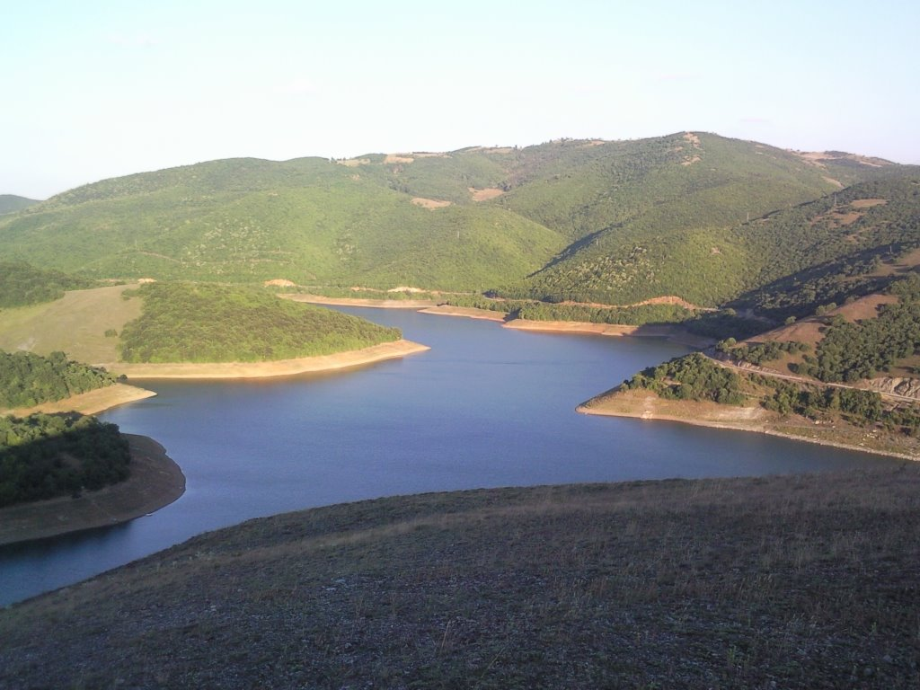
Picture 7: Badovc Lake

Organization in the tourism sector

The touristic transport is at a satisfactory level, and therefore services are provided to tourists.
The Tourist Organization “Gracanica” has a tour guide for visits to the attractions within the territory of municipality of Gracanica. Hotels and restaurants in this location offer traditional Kosovo food; there are cultural-artistic associations that offer diverse cultural programs for tourists; this municipality provides tourist packages including all services.
There are touristic packages provided by agencies and organisations, organised within the Tourist Organization of Gracanica. The municipality has a Tourist Information Centre which is run by the Tourist Organization. Gracanica has two tour guides (the Gracanica Monastery and the Ulpiana Archaeological Park). Tourist Organization “Gracanica” has tour guides, however, the problem is that they are uneducated and do not possess certificates. Tourist Organization “Gracanica” promotes tourist packages, tourism manifestations in the region and festivals through its website www.togracanica.org
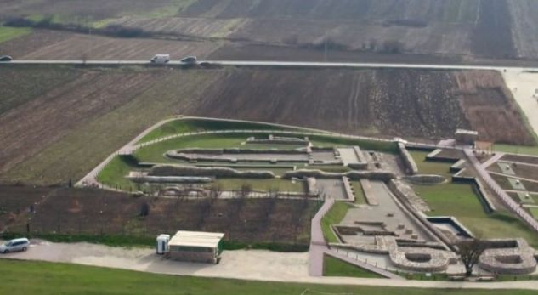
Picture 8: Ulpiana Archaeological Park
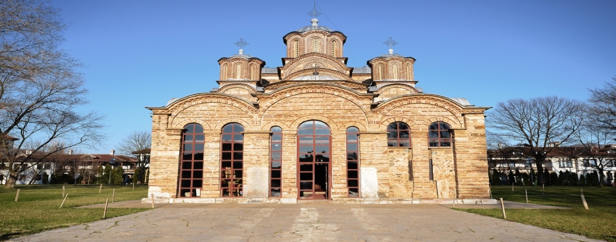Picture 9: Gracanica Monastery
Accommodation capacities
The municipality of Gracanica has 11 accommodation facilities providing solid accommodation capacities:
4 hotels with a capacity of 200 rooms,
4 motels with a capacity of 79 rooms
3 hotels with a capacity of 220 rooms

Possible projects for tourism development in the municipality of Gracanica:
- Design of urban and detailed plans of tourist localities,
- Badovc Touristic locality ,
- Ulpiana Touristic locality ,
- Monastery Touristic locality ,
- Organizational and institutional scope of the tourism sector,
- Completion of the tourist legal infrastructure, under the competence of local government,
- Support to cultivation of traditional gastronomy,
- Support to development of tourist marketing and promotion at the municipal level,
- Identification and promotion of marked days, manifestations at the municipal level,
- Development of tourist signalling project,
- Support to the development of human resources in the tourism sector;
- Creating the conditions for development of rural tourism,
- Protection and stimulation of folkloric, artisan and ethnographic activities,
- Manifestation and promotion of marked days,
- Creating facilitations for investment in tourism.

Conclusions and recommendations

In order to develop tourism in the municipality of Prishtina, the following is considered as necessary:
Design of urban and detailed plans of tourist localities:
- Tourist attraction of Badovc Lake, with the aim of creating conditions for: cycling, horseback riding, skating, outdoor excursions, picnics, camping, bird watching, botanical garden, etc.
- Ulpiana Touristic locality ,
Completing and implementing local legal infrastructure,
Protecting and encouraging craft and ethnographic activities,
Stimulating the development of traditional foods and specialties,
Developing the promotion of local tourism,
Creating the conditions for development of rural tourism,
Manifestation and promoting specific days,
Development of the unique institutional tourism marking project,
Development and building capacities of human resources in the tourism sector,

MUNICIPALITY OF OBILIQ
The Municipality of Kastrioti does not have a tourism development plan.
Tourist localities in the municipality of Kastriot are: Mazgiti, Graboci, Siboci, Breznica
Tourist attractions:
Behrama water mill,
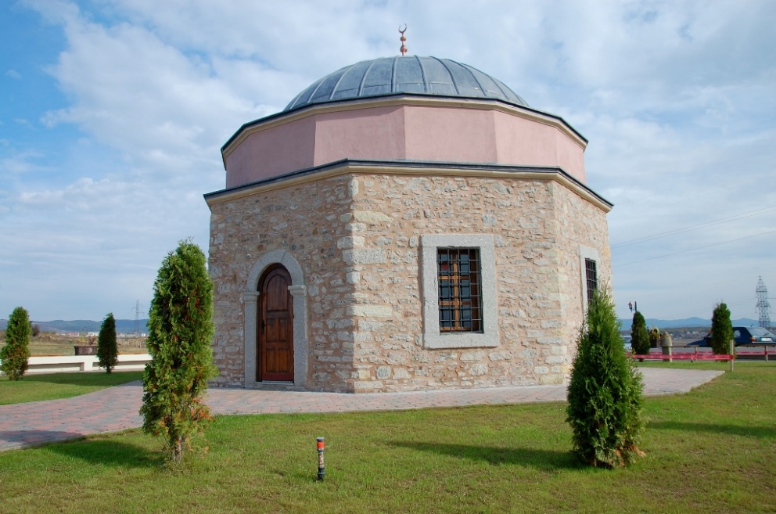
Hysenaj water mill,
Lapidary of Freedom/ Hamidi,
MUSEUM house /Hamidi,
Source of mineral water.

Picture 10: Tomb of Sultan Murat

Accommodation capacities
The Municipality of Obiliq has 7 accommodation facilities with 114 rooms and 126 beds.

Organization in the tourism sector
There is no plan or strategy for tourism development in the municipality of Obiliq,
- There is no tourist information office,
- There is no tourist website,
- There is no tourist guide and tourist companion,
- There is no tourist signalling,
- There is no tourist package arrangement

Conclusions and recommendations
In order to develop tourism in the municipality of Prishtina, the following is considered as necessary:
Design of urban and detailed plans of areas and localities:
Breznica tourist area - with the purpose of creating conditions for cycling, horseback riding, excursions in nature, picnics and camping, bird watching, botanical garden etc.
Completion and implementation of local legal infrastructure,
Protection and stimulation of handicraft and ethnographic activity,
Development of traditional foods and specialties,
Development of the local tourist promotion,
Creating the conditions for development of rural tourism,
Manifestation and promoting specific days,
Designing a unique institutional tourist marking project
Human resources level development and building in the tourism sector,
Restoration, valorisation, and conversion of some cultural heritage sites into tourist localities such as Water Mill of Behramajve (Mulliri i ujit i Behramajve), Water Mill of Hysenajve (Mulliri i ujit i Hysenajve), Lapidary of Freedom (Lapidari i Lirisë/Hamidi), MUSEUM house (Shtëpia MUZE/Hamidi), Source of mineral water.

MUNICIPALITY OF FUSHE KOSOVA

Natural heritage facilities
“Parku i Pishave” in Sllatina e Vogel, a recreational and sports area, with a surface area of 120ha of black and white pines, abundant in diverse flora and fauna, with over 200 species of vascular plants and wildlife such as mammals, reptiles, birds, insects, etc.
Ligatina e Hencit, with an area of 110 ha, declared as a special protected area of birds/over 80 species, a pond and an accumulative lake.
The caves in the Castle of Bardhi i Madh and Harilaq, which were once used as mines, have been closed for some time and need to be explored and restored
The endemic habitat of Forsythia in Harilaq as an area that must be protected because of its specific natural values as a natural monument of botanical character.
Two mini-lakes at the Gospoja Mountain, with a quite significant biodiversity, a protected landscape area with aesthetic and ecological values.

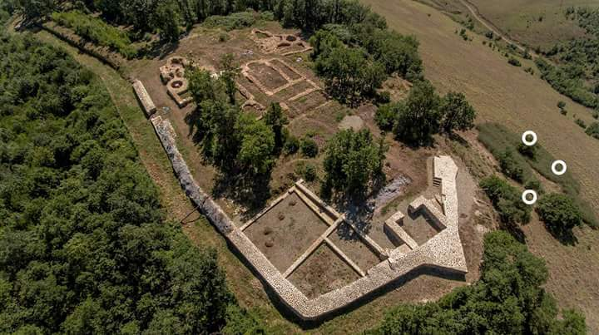
Picture 11. Harilaq fortress

Accommodation capacities
The Municipality of Fushe Kosova has the following accommodation capacities:
22 accommodation facilities, 336 rooms, and 381 beds

Organization in the tourism sector
This municipality does not have an adequate institutional organization in the field of tourism:
- There is no Tourism Development Strategy,
- There is no tourist information office,
- There is no tourist website,
- There is no tour guide and chaperone,
- There is no tourist marking,
- There are no tourist package arrangements
Potential projects for tourism development in the Municipality of Fushe Kosova:
1. Drafting urban regulatory plans for tourist localities:
- Touristic locality of "Parku i Pishave" in Sllatina,
- Touristic locality of Harilaq,
- Touristic locality of Hencit,
- Location of rehabilitation and recreation centre,
- Organizational and institutional scope of the tourism sector,
2. Completion of the tourist legal infrastructure, under the competence of local government,
3. Stimulation of development, protection of craft activities and ethnographic heritage,
4. Support to cultivation of traditional gastronomy,
5. Support to development of tourist marketing and promotion at the municipal level,
6. Identification and promotion of marked days, manifestations at the municipal level,
7. Development of tourist signalling project,
8. Support to the development of human resources in the tourism sector,
9. Creating facilitation for investment in tourism.

Conclusions and recommendations
In order to develop tourism in the municipality of Municipality of Fushe Kosova, the following is considered as necessary:
Design of urban and detailed plans of tourist localities:
Touristic locality of “Parku i Pishave” in Sllatina e vogel, with the purpose of creating conditions for cycling, horseback riding, outdoor excursions, picnics and camping, bird watching, botanical garden etc.
Touristic locality of Harilaq,
Ligatina e Hencit,
Endemic habitat of Forsythia in Harilaq,
Caves in the Castle in Bardhi i Madh and Harilaq Fortress,
Completion and implementation of local legal infrastructure,
Protecting and encouraging craft and ethnographic activities,
Development of traditional foods and specialties,
Developing the promotion of local tourism,
Establishment of conditions for the development of rural tourism,
Manifestation and promoting specific days,
Construction of a unique institutional project of tourist marking,
Human resources level development and building in the tourism sector

MUNICIPALITY OF LIPJAN
Tourist localities are: Marble Cave in Gadime, National Park in Blinaja.
As tourist attractions that would attract tourists are: Marble Cave in Gadime,
National Park in Blinaja, Landscapes of the gorges, Krojmir Shale, Baince Kishnapole, Zhegovc, Janjeva as the place of antiquity and the Tomb of Isak Baba, century XVIII.
This municipality has tourist companies, private agencies for tourism services. There is no tourist packages provided that includes from departure to arrival at the destination. Additionally, Lipjan also has tourist agencies (Tour operators) providing tourist services, whereas the village of Janjeva is considered as a touristic village.
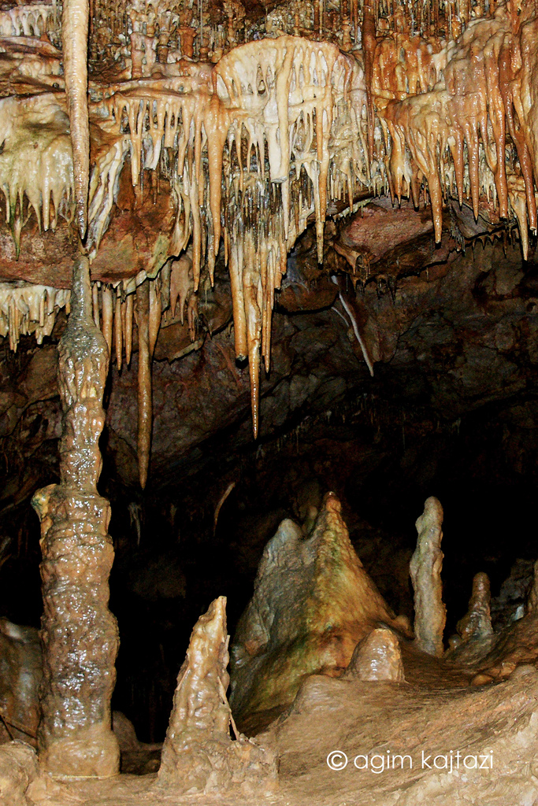
Picture 12. Cave of Gadime

Accommodation capacities
The Municipality of Lipjan has the following accommodation capacities:
23 accommodation facilities, 150 rooms, and 152 beds

Organization in the tourism sector
Lipjan no longer has a tourist information office, and does not have a regulated touristic marking system (Signs for touristic places). There is a tour guide (cicerone), which operates in the Marble Cave in the village of Gadime. There is no tourist chaperone (competent person accompanying tourists), no marketing and no tourist promotion officer (tourist web pages, brochures, flyers).

Conclusions and recommendations
In order to develop tourism in the municipality of Lipjan, the following is considered as necessary:
Design of urban and detailed plans of tourist areas and localities:
- Tourist area of Blinaja - with the purpose of creating conditions for cycling, horseback riding, outdoor excursions, picnics and camping, bird watching, botanical garden etc.
- The tourist area of the town of Janjeva: rural tourism, cultural tourism, cycling, horseback riding, outdoor excursions, picnic etc.
Completing and implementing the local legal infrastructure,
Protecting and encouraging craft and ethnographic activities,
Development of traditional foods and specialties,
Developing the promotion of local tourism,
Creating the conditions for development of rural tourism,
Manifestation and promoting specific days,
Designing a unique institutional project of tourist marking,
Development and building capacities of human resources in the tourism sector,

MUNICIPALITY OF SHTIME

Shtime is a town and municipality located in the district of Ferizaj, Kosovo. The municipality’s territory covers an area of 134 square kilometres.
Accommodation capacities
The Municipality of Shtime has the following accommodation capacities:
13 accommodation facilities, 70 rooms, and 80 beds
Organization in the tourism sector
Municipality of Shtime has the Strategy for Development of Rural Tourism 2015 - 2019.
There are no organized tourist services (services offered to tourists). There are no tourist package offers (the overall services offered to tourists from start departure to the arrival at the destination). Currently there are 15 tourist transport businesses operating in the territory of the municipality of Shtime. There is no tourist information office. There is no tourist signalling (Orientation signs to touristic sites). There is no tour guide or tourist chaperone. No marketing and tourist promotion officer (tourist web pages, brochures, flyers).

Tourist localities in the Municipality of Shtime are:
Llanisht, Topilla, Devetak, Carraleva, Ranca, Duga, Karaqica, Pjetershtica, Reçaku. The physical infrastructure to these tourist localities in general is built.
Tourist attractions, that would be interesting to tourists: Llanisht Gorge, Caves, Memorial Complex “Masakra e Reçakut”, the tomb of “Ahmet Shtime”, Cemetery of Martyrs in Shtime and Mollopolc, Towers, Mills, Old Houses in Topilla.
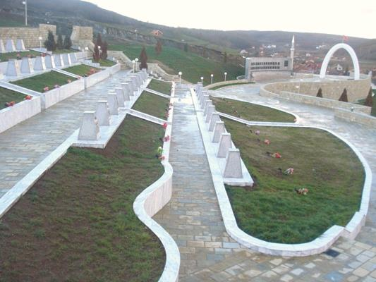
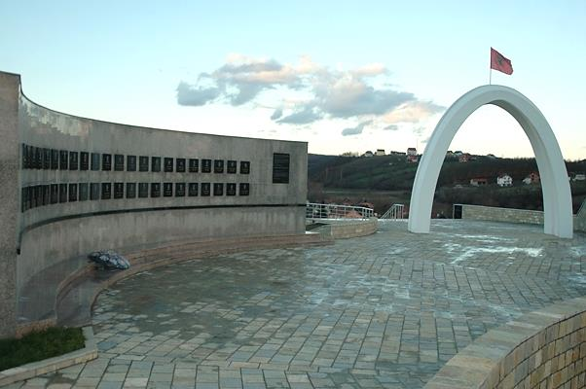
Picture 13. Memorial Complex "Masakra e Reçakut" - Reçak,

Conclusions and recommendations
In order to develop tourism in the municipality of Shtime, the following is considered as necessary:
Design of urban and detailed plans for tourist areas and localities:
Tourist area of “Caraleva Gorge”, with the purpose of creating conditions for cycling, horseback riding, hunting, outdoor excursions, picnics and camping, bird watching, botanical garden etc.
Touristic locality “Llanisht Gorge”,
Touristic locality “Mollopolc Gorge”,
Touristic locality “Shpella e Lakuriqëve” (Bat Cave),
Touristic locality “Imer Devetaku Cave” – Devetak, Touristic locality “Cave of Pjetërtshtica” – Pjetershtica, Touristic locality “Pines of Shtime”,- Touristic locality , River Shtimjanja, Touristic locality “Vrella e Zezë – Petrova”,- Touristic locality “Kroni i Zanave – Devetak”, Touristic locality , beautiful vegetation, natural/virgin landscapes in the mountainous areas, a special type of flower called “Peony flower”, mountain tea and many types of plants, oak trees in: Mollopolc, Godanc i Ulët, Godanc i Epërm, Rashinca, Karaçica and Gështenjat in Shtime, Creating the conditions for development of rural tourism, Completing and implementing local legal infrastructure,
Protecting and encouraging craft and ethnographic activities,
Development of traditional foods and specialties, Developing the promotion of local tourism, Manifestation and promoting specific days, Designing a unique institutional project of tourist marking, Development and building capacities of human resources in the tourism sector,

MUNICIPALITY OF DRENAS
The city of Drenas is located in central Kosovo, namely between the mountains of Cicavica in the east, the mountains of Drenica in the north and Kosmacin in the west.
Accommodation capacities
The Municipality of Drenas has the following accommodation capacities: 6 accommodation facilities, 77 rooms, and 77 beds.
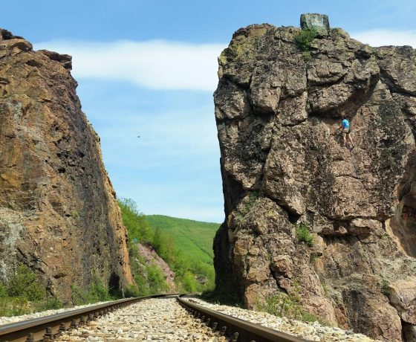
Picture 14. Guri i Plakës (Old Woman Rock)
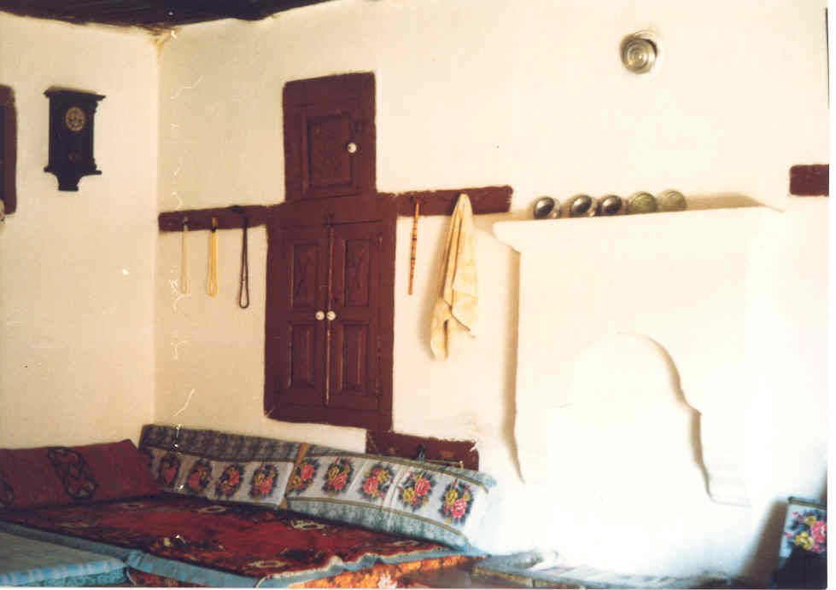
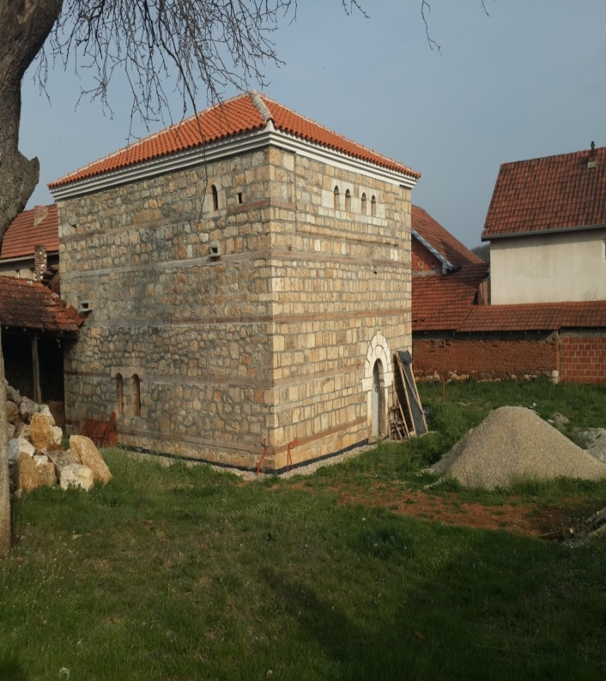

Picture 15. Tower of Habib Xhemajli

Organization in the tourism sector
There is no strategy for development of tourism,
There is no tourist information office,
There is no tourist website, There are no tourist guides and chaperons, No tourist signalling There are no tourist package arrangements

Conclusions and recommendations
In order to develop tourism in the municipality of Prishtina, the following is considered as necessary:
Design of urban and detailed plans of tourist areas and localities:
The tourist area of Vasileva Lake, with the purpose of creating conditions for cycling, horseback riding, skating, outdoor walking, picnic and camping, bird watching, botanical garden etc.,
The Touristic locality of Llapushnik, for the purpose of creating conditions for cycling, horse riding, skating, walking outdoors, picnic and camping, bird watching, botanical garden etc., Completing and implementing the local legal infrastructure,
Creating the conditions for development of rural tourism,
Protecting and encouraging craft and ethnographic activities,
Development of traditional foods and specialties,
Development of a local tourist promotion,
Manifestation and promotion of specific days,
Development of the unique institutional tourism marking project,
Development and building capacities of human resources in the tourism sector.

RECOMMENDATIONS ON THE TOURISTIC REGION IN GENERAL

Based on the findings above, it is necessary to work on the following recommendations:
Access to the processing of products and new tourist packages based on the results found,
Training of rural families to work in family or rural tourism,
Provision of training on forms, methods and techniques to be used in ensuring a broad community participation in local development processes,
Increase cooperation between local and regional operators,
Cooperation between local government, communities and private operators in developing and implementing the strategies, plans and programs for development of tourism,
Multiplication and qualitative improvement of tourism products,
Design of the logo for every rural tourist destination,
Improvement of Medical services,
NACs must be reorganized in order to further develop traditional culture,
Create entertaining environments, not only for tourists but also for the hosting community,
Renovate the handicraft centres and handicraft work,
Increase infrastructure investments in touristic areas,
Enforce laws on environmental protection,
Preserve and invest in natural, cultural and archaeological monuments,
Promote areas that represent interests,
Prevent forest damages and ensure afforestation, Prevent illegal constructions, Establish information offices in all tourist areas, Improve infrastructure at tourist attractions, Increase the community’s opportunities to invest, through donors and public sector, Involve the community in preserving the attractions and maintaining the security.

CONCLUSION

In cooperation with the Municipal Directorates on Economic Development and Directorates of Culture, Youth and Sports, whereby some provided more and some less data on cultural and natural heritage regarding touristic potentials and current state of tourism. We have managed to prepare a decent report in order to create an overview of the state of play and opportunities in the municipalities of the region for a rapid development of this economic sector that creates opportunities for development of many other economic sectors, thus increasing employment and living standard and providing a better life for our citizens in general. Therefore, we hope that this report will provide a clearer picture to respective local and central administrations and investors with regard to investment opportunities, employment, and development of tourism in these tourist regions.

It is our duty to raise the awareness of central and local institutions with regard to creating conditions for development of tourism, drafting clear tourism development policies, supporting tourism business initiatives, developing human resources, completing the infrastructure, attracting investment etc.
More attention should be paid to preserving and maintaining our cultural and historical heritage facilities, with the purpose of valorising and transforming them into products and tourist offers. This also applies to the numerous natural heritage site and attractions. Our institutions should provide the necessary infrastructure and create more favourable investment opportunities in many tourism projects in this region and beyond.
Those mentioned above apply to all types of tourism that our culture and natural heritage can provide. In addition to the popular tourist products, nowadays there are vast opportunities for development of new attractive tourist products that would attract certain clientele from abroad and from within country, such as: outdoor walking, skating, horseback riding, grass sliding, kayaking, ice hockey, golf, biking, mountain biking, boating, canoeing, kayaking, rafting, bird watching, cave tours and children's camps, carnivals or circus etc. and various activities such as: festivals, animal racing, apple gathering, artistic performances, sheep shearing, milk processing, hand spinning etc.

Tourism Coordination Team for implementation of the Activity, "Identification of Tourist Product in the Prishtina Region"

Department of Industry, Ministry of Trade and Industry
Division of Tourism, Ministry of Trade and Industry
Directorate of Economy and Development in the Municipality of Prishtina
Directorate of Culture, Youth and Sports in the Municipality of Prishtina
Directorate of Economy and Development in the Municipality of Podujeva
Directorate of Culture, Youth and Sports in the Municipality of Podujeva
Directorate of Economy and Development in the Municipality of Obiliq
Directorate of Culture, Youth and Sports in the Municipality of Obiliq
Directorate of Economy and Development in the Municipality of Fushë Kosova
Directorate of Culture, Youth and Sports in the Municipality of Fushë Kosova
Directorate of Economy and Development in the Municipality of Lipjan
Directorate of Culture, Youth and Sports in the Municipality of Lipjan
Directorate of Economy and Development in the Municipality of Shtime
Directorate of Culture, Youth and Sports in the Municipality of Shtime
Directorate of Economy and Development in the Municipality of Drenas
Directorate of Culture, Youth and Sports in the Municipality of Drenas

