 | 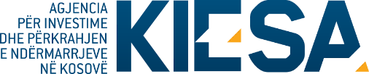
Republika e Kosovës
Republika Kosova-Republic of Kosovo
Qeveria - Vlada – Government

Ministria e Industrisë, Ndërmarrësisë, Tregtisë dhe Inovacionit - Ministarstvo Industrije, Preduzetništva, Trgovine i Inovacija - Ministry of Industry, Entrepreneurship, Trade and Innovation

Kosovo Investment and Enterprise Support Agency

APPLICATION
(for three Lots)

For participation in the financial subsidy for the public call for financial support for MSMEs in the Creative Industry sector (CI)

(To be completed by the applicant)

I. GENERAL INFORMATION ABOUT THE APPLICANT
- Name and surname (Business owner)
(If the authorized person is different from the owner of the applicant entity, please attach a notarized authorization.).
- Personal number
- Date of birth
- Address (Municipality)
- Nationality
- Gender
- Profession
- Phone number
- E-mail address
- Enterprise website (if applicable)
- Business name
- Business number
- Business registration date
- Type of business (Limited liability, individual business, partnership, etc.)
- Full business address
- Information about the sector in which your business operates
- Application lot
- Requested grant amount (EURO)
- Provide an overview of your current business and your product:
- Number of new employees planned to be employed upon receiving the grant:
Challenges/risks to be managed to mitigate their negative impact:
- Production capacities and expansion forecasts for the following years:
- Other, if applicable:

