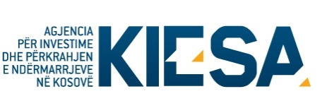

Republika e Kosovës
Republika Kosova-Republic of Kosovo
Qeveria –Vlada-Government
Ministria e Tregtisë dhe Industrisë-Ministarstvo Trgovine i Industrije- Ministry of Trade and Industry

Agjencia për Investime dhe Përkrahjen e Ndërmarrjeve në Kosovë (KIESA)
Agencija za Investicije i Podršku Preduzeča na Kosovu (KIESA)
Kosovo Investment and Enterprise Support Agency (KIESA)

DECLARATION UNDER OATH

I, the undersigned, representative of the applying subject in public call for MSME grants, verify that we meet the eligibility requirements for participation in this call.

I acknowledge that I have not applied or did not receive grant support from MTI for the same activity for the period of last two years.

I declare that I have no obligation regarding MTI's prior financial support.

I accept the possibility of criminal and civil sanctions, fines and penalties, if I, due to negligence, file any document or declaration containing false or misleading information.

Identification of the subject
Name of the subject
Complete address
Represented by:
Name and surname
Position
Signature
Date

