

REPUBLIKA E KOSOVËS/REPUBLIKA KOSOVA/ REPUBLIC OF KOSOVO
QEVERIA E KOSOVËS / VLADA KOSOVA /GOVERNMENT OF KOSOVA

Ministria e Tregtisë dhe industrisë/ ministarsvo trgovine industrije/
MINSTRY OF trade and industry

Departamenti i tregtise / Department trgovine / department of trade

Analysis on CEFTA Market Access Database on Barriers

- Introduction

Since 2009 CEFTA Parties have been systematically identifying and solving barriers in trade in goods. In 2012 the Parties decided to expand the scope to a broader definition of the barriers including services and to make the methodology internationally comparable while applying the UNCTAD classification of non-tariff measures. In 2013 Parties were eager to go online with a new feature of the database which allows for more standardised identification and reporting on the barriers and establishes an interaction between the recorded market access barriers and the trade volume of the product subject to the relevant barriers. The issue of unjustifiable barriers to trade among the CEFTA countries is a recurring theme in official CEFTA meetings and a source of friction and constant complaints by traders, both exporters and importers. A number of studies have shown that inter-regional trade is well below potential, and such situation, in a tariff free context, is partly attributed to the existence of unjustifiable obstacles to trade. This situation persist despite the fact that CEFTA includes provisions for the elimination of non-tariff-barriers (NTBs) and that this task falls within the mandate of institutional structures created under CEFTA: the Subcommittee on Technical Barriers to Trade (TBTs) and NTBs, the Subcommittee on Agriculture and Sanitary and Phyto-sanitary (SPS) Issues, and the Subcommittee on Customs and Rules of Origin. Furthermore, in this area a main objective to be achieved through the” Consolidated Multi-annual Action Plan for Regional Economic Area in the Western Balkans 6”(MAP) is the creation of NTMs and TDMs-free region. Kosovo exporters are confronting obstacles of different nature when exporting to CEFTA markets. There are two main types of obstacles: those emerging from political considerations related to not recognition of Kosovo’s independence by three members of CEFTA: Serbia, Bosnia and Herzegovina and Moldova; and procedural obstacles of different nature which are applied by all members of CEFTA.

- An overview of cases recorded in CEFTA MABD

It is worth mentioning that in terms of updating of the CEFTA Transparency Pack and its component of Market Access Barriers Database remains weak from CEFTA members. During the chairmanship of Kosovo, some initiatives through the Working Group meeting on technical measures and Subcommittee on Nontariff Measures were undertaken and required since CEFTA MABD was seen as partially updated, despite the reminder of the Chair in Office. Besides, the Chair in Office has sent a written instruction to the Secretariat to send a regular reminder to all CEFTA Parties to keep the CEFTA MABD regularly updated. Unfortunately, this has not regularly happened; therefore, the MABD seems not to be appropriately updated since 2016. Regular updating is necessary; hence, as highlighted above CEFTA Secretariat was instructed by the Chair to send a regular reminder to all CEFTA Parties.

  - The overall distribution of cases recorded in CEFTA MABD and by other sources

Despite such approximation, NTBs in the CEFTA Region still exist due to the following reasons: First, non-recognition of certification at 1st or 2nd Party levels; second, the absence of mutual recognition at regional or bilateral levels, third, the excessive documentary requirements burden certification stage; fourth, the cumbersome compliance procedures due to low-risk management, excessive sampling, double testing, requiring testing in third parties etc. and last but not least, the revenue collection remains a high strategic priority to ease national budgetary issues – Offsetting facilitated preferential trade with FTA partners with revenue collection motivated certification and compliance in the regional trade. However, to better understand the whole nature of the application of NTBs among CEFTA countries several figures regarding the cases by applying measures, reporting cases, barriers by sector, cases by status and cases by category are shown below. As figure 1 shows, from 2013 to 2016, in total 102 non-tariff barriers were applied among CEFTA member states, out of them, 78 cases or 76.5% of total cases were solved. While 24 or 23.5% of cases of non-tariff barriers imposed by CEFTA member states remain as unsolved cases, in terms of countries, as it can be seen Serbia has applied the most significant number of NTBs cases with a total of 37 applied measures, followed by Bosnia and Herzegovina. Regarding Kosovo, there are 14 cases of NTBs, which only 7 or 50% of the selected general cases are solved. For more information see Fig 1.
Figure 1:
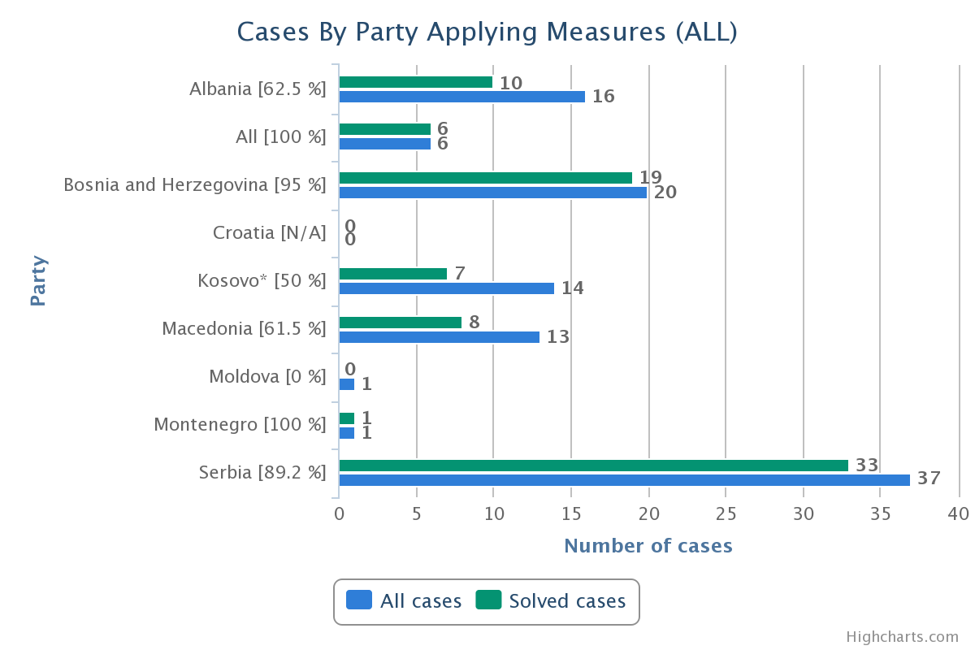
Also, throughout 2013 - 2016, the reported NTBs by CEFTA member states marked 107 cases. Out of the reported cases, 84 of them are solved or expressed in percentage, 78.5%, while 23 cases remain unresolved or 21.5%. The country that most reported identified NTB cases is Serbia with 32 reported cases, followed by Bosnia and Herzegovina 28 cases. Whereas, Kosovo reported 20 cases of non-tariff barriers and 18 cases or 90% of the reported cases were solved.

Figure 2:
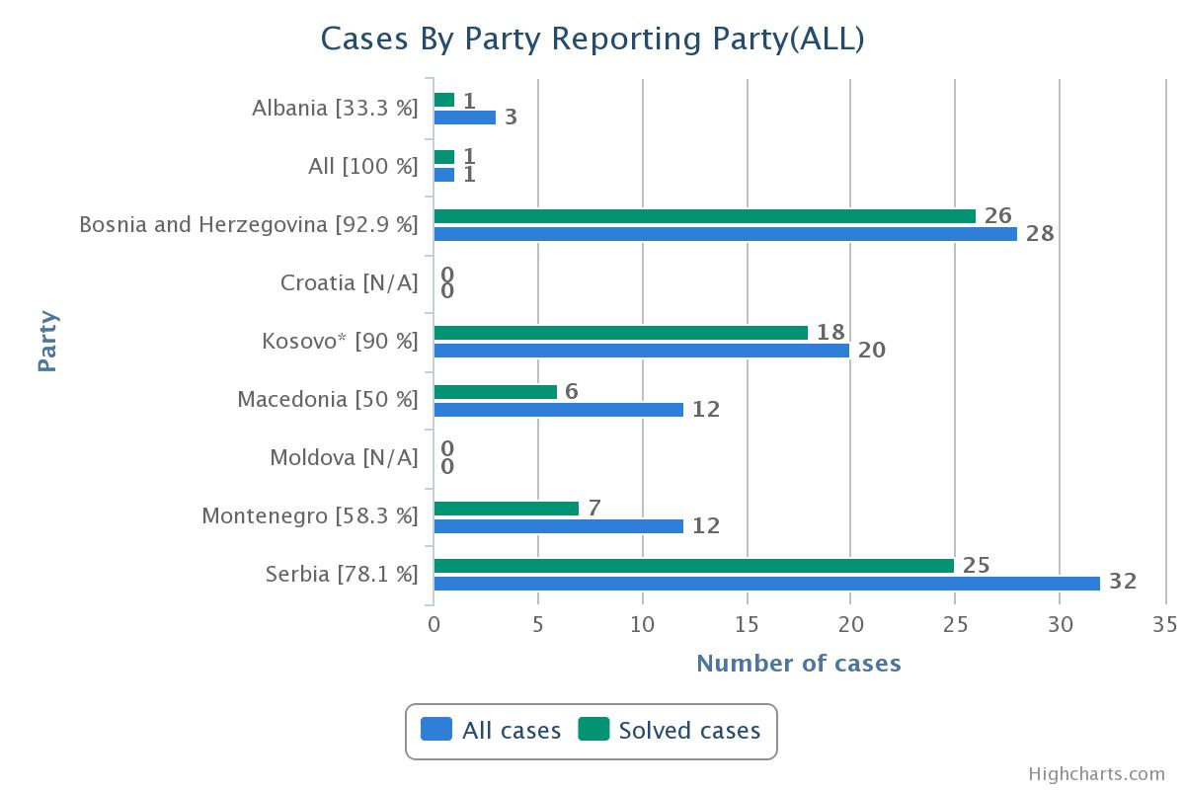
Figure 2 explains cases by reporting party, the number of cases by each party. As shown in figure 2 Albania has reported only 3 cases; BiH has reported 28 cases; while Kosovo has reported 20 cases; North Macedonia has reported 12 cases; Montenegro has reported 12 cases; Serbia has reported 32 cases; and Moldova 0 cases. To better understand all the nature of NTBs application by CEFTA countries, in particular, the types of products to which non-tariff barriers have been applied, there are some figures on sectoral cases. Therefore, it is worth mentioning that from the data updated it is clear that most affected sectors by NTB are the following sectors: Prepared Foodstuffs; Beverages, Spirits and Vinegar; Tobacco and Manufactured Tobacco Substitutes with participation in 33.33% of the total number of cases presented, Vegetable Products sector with 32.05% and Live Animals; Animal Products with 15.38%. From the presented data, we understand that these 3 sectors account for 80.76% of the total reported cases for non-tariff barriers identified within CEFTA countries.
Figure 3:

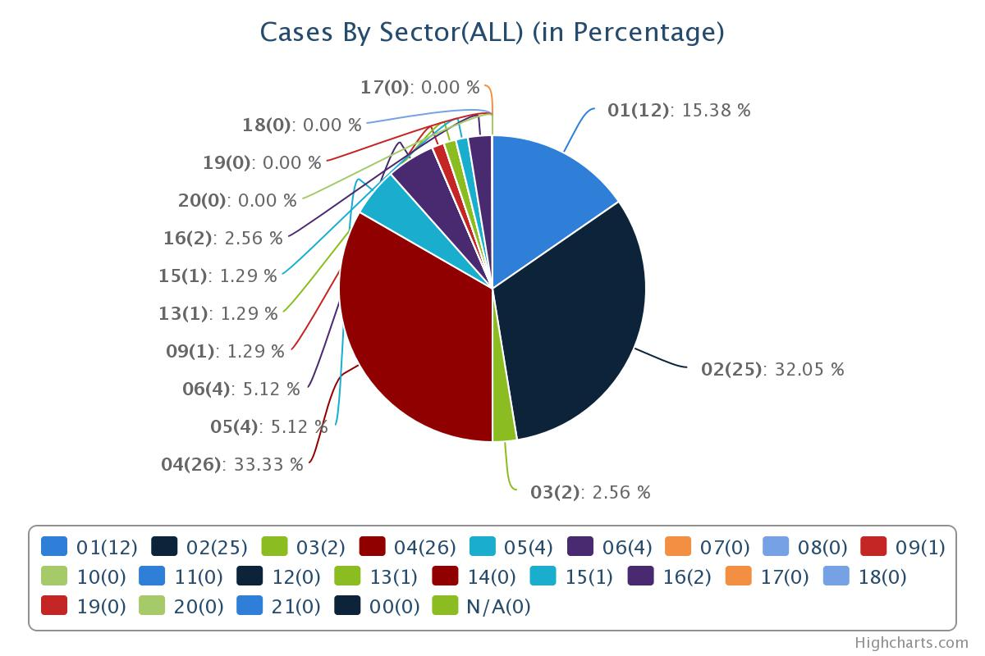

- 01 - Live Animals; Animal Products
- 02 - Vegetable Products
- 03 - Animal or Vegetable Fats and Oils and Their Cleavage Products; Prepared Edible Fats; Animal or Vegetable Waxes
- 04 - Prepared Foodstuffs; Beverages, Spirits and Vinegar; Tobacco and Manufactured Tobacco Substitutes
- 05 - Mineral Products
- 06 - Products of the Chemical or Allied Industries
- 07 - Plastics and Articles Thereof; Rubber and Articles Thereof
- 08 - Raw Hides and Skins, Leather, Furskins and Articles Thereof; Saddlery and Harness; Travel Goods, Handbags and Similar Containers; Articles of Animal Gut (Other than Silk-Worm Gut)
- 09 - Wood and Articles of Wood; Wood Charcoal; Cork and Articles of Cork; Manufactures of Straw, of Esparto or Other Plaiting Materials; Basketware and Wickerwork
- 10 - Pulp of Wood or Other Fibrous Cellulosic Material; Recovered (Waste and Scrap) Paper or Paperboard; Paper and Paperboard and Articles Thereof
- 11 - Textiles and Textile Articles
- 12 - Footwear, Headgear, Umbrellas, Sun Umbrellas, Walking-Sticks, Seat-Sticks, Whips, Riding-Crops and Parts Thereof; Prepared Feathers and Articles Made Therewith; Artificial Flowers; Articles of Human hair
- 13 - Articles of Stone, Plaster, Cement, Asbestos, Mica or Similar Materials; Ceramic Products; Glass and Glassware
- 14 - Natural or Cultured Pearls, Precious or Semi-Precious Stones, Precious Metals, Metals Clad with Precious Metal and Articles Thereof; Imitation Jewellery; Coin
- 15 - Base Metals and Articles of Base Metal
- 16 - Machinery and Mechanical Appliances; Electrical Equipment: Parts Thereof; Sound Recorders and Reproducers, Television Image and Sound Recorders and Reproducers, and Parts and Accessories of Such Articles
- 17 - Vehicles, Aircraft, Vessels and Associated Transport Equipment
- 18 - Optical, Photographic, Cinematographic, Measuring, Checking, Precision, Medical or Surgical Instruments and Apparatus; Clocks and Watches; Musical Instruments; Parts and Accessories Thereof
- 19 - Arms and Ammunition; Parts and Accessories Thereof
- 20 - Miscellaneous Manufactured Articles
- 21 - Works of Art, Collectors Pieces and Antiques
- 00 - All
- N/A - N/A

It is worth noting that most of the restrictive measures imposed by all CEFTA countries are mainly concerning the nature of Sanitary and phytosanitary measures. In total 28.70% of the cases followed by price control measures, including additional taxes and charges of 17.59%, as well as technical barriers to trade of 12% etc.

Figure 4:
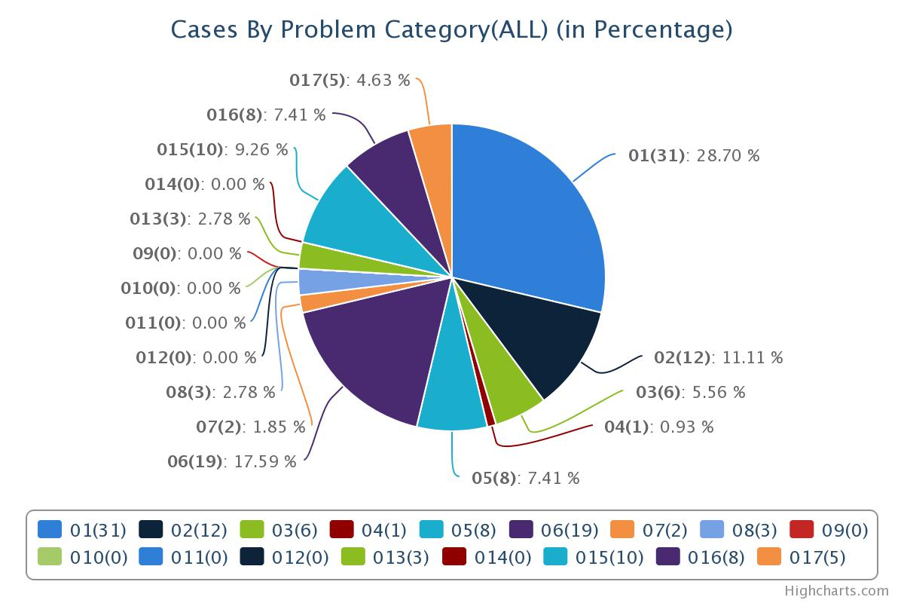
- 01 - A Sanitary and phytosanitary measures
- 02 - B Technical barriers to trade
- 03 - C Pre-shipment inspection and other formalities
- 04 - D Contingent trade protective measures
- 05 - E Non-automatic licensing, quotas, prohibitions and quantity control measures other than for SPS or TBT reasons
- 06 - F Price control measures including additional taxes and charges
- 07 - G Finance measures
- 08 - H Measures affecting competition
- 09 - I Trade-related investment measures
- 010 - J Distribution restrictions
- 011 - K Restriction on post-sales services
- 012 - L Subsidies (excluding export subsidies under P7)
- 013 - M Government procurement restrictions
- 014 - N Intellectual property
- 015 - O Rules of origin
- 016 - P Export related measures
- 017 - N/A

While the figure 5 shows the total distribution of cases registered in CEFTA MABD belonging to NTB measures are 108 (84 solved), (11 pending) and 13 new cases filed in 2016.

Figure 5:
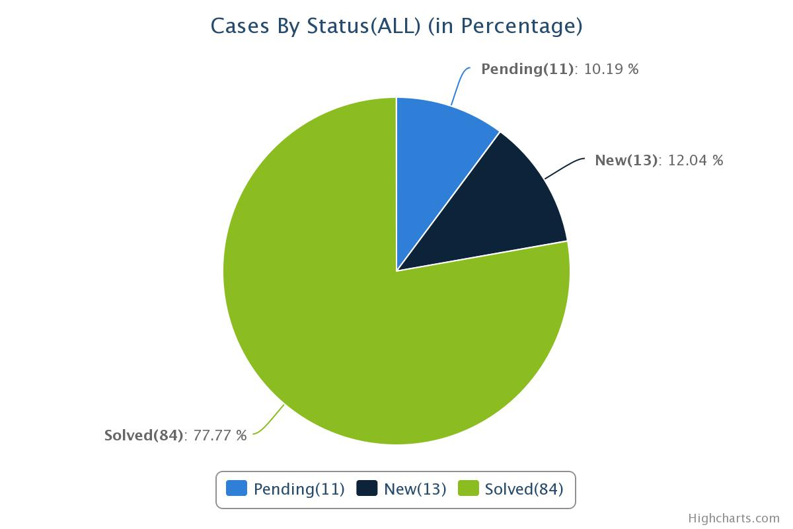
As explained by figure 5 the cases by the status that have been solved are 77.77%, 10.19% of them are still pending, and 12.04 % are new cases.

- Reporting cases

It is worth noting that most of the restrictive measures imposed by all CEFTA countries against Kosovo are inserted into the Market Access Barriers Data-Base, and if we have a look into this Data Base in particular before 2016 related to the notification of cases, it can be seen that Kosovo has mostly submitted notifications as a reporting country and is still waiting for the submitted issues to be adequately addressed correctly, especially when it comes to cases with Bosnia and Hercegovina and Serbia, whether they are related to SPS, TBT or transit issues. It is worth noting that the MABD seems not to have been regularly updated by all members since 2016 due to technical problems in its operation which have already been overtaken by the beginning of 2019.

- Applicability of CEFTA tools to eliminate structural NTBs

There are some signs that at least the number of barriers could be reduced if not eliminated at all. For instance, AP 5 aims to create two regional mutual recognition to respond to NTBs stemming from non-recognition of certification. Likewise, AP 5 aims to improve risk management systems via an extensive electronic exchange of data – Policymakers in revenue collection should be aware of that revenue collection may increase by efficient use of risk systems as well as it aims to enhance transparency and offer stronger discipline in documentary requirements and fees/charges linked to documentary requirements. However, AP5 it is not yet fully being implemented as well as Kosovo has not yet ratified it. In addition to this, further steps are necessity: For instance, CEFTA Transparency Market needs to be upgraded and updated for transparency, and future CEFTA AP 7 is needed to in order to eliminate any further remaining NTBs.

- Concluding remarks

- As long as budgetary issues / bad ratio of direct and indirect taxation remain, NTBs may remain due to certification and compliance related issues.
- Approximation to EU laws and international standards may contribute but not solve the NTBs unless mutual recognition programmes exist.
- CEFTA legal instruments are almost sufficient but need further improvement especially of the dispute settlement mechanism which is crucial in order to solve unjustified trade barriers.
- Economic competitiveness and access to markets should be taken into account as main policy objectives in the elimination of NTBs.
- Creating MRA among CEFTA countries based on MAP REA
- As it is set out in the trade component in MAP/REA, CEFTA Secretariat to prepare a report on annual basis on the main impediments to trade. The report will in particular reflect the current obstacles faced by companies and breach in the level-playing field that should prevail for companies within the region.
- Taking more seriously the main obstacles identified by GIZ, ITC and OECD and the provided recommendations.
- Kosovo has not been able to reap all the expected trade-related benefits of its participation in the CEFTA Agreement, in particular when comparing with the performance of other members of the regional grouping. Kosovo has experienced a structural and growing deficit in its regional trade, becoming a main import destination for exports of other CEFTA Members.

