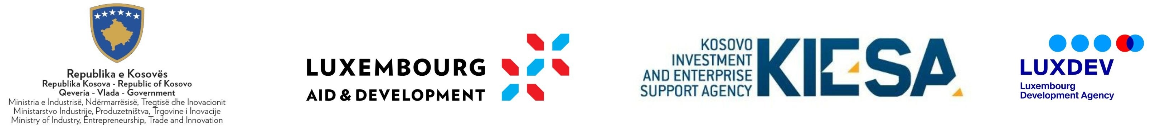

Statement on receipt of funds

By signing this statement, I hereby confirm that all the information contained in this application is complete and accurate. If it is proven that I have submitted false or inaccurate information or data, including the criteria presented in the application file as an applicant to this grant scheme, I shall bear responsibility for the punitive consequences in accordance with the relevant applicable laws in Kosovo.
I am fully aware that completing the application process does not guarantee the award of the grant requested from MIETI/KIESA under this grant scheme.

- Have you received funds under AI 01/2018 from other funding sources for the same activities?

Circle:
Yes No

Personal contacts:

Full name: (first name) (middle name) (last name))

Position:

Date:

Signature:

