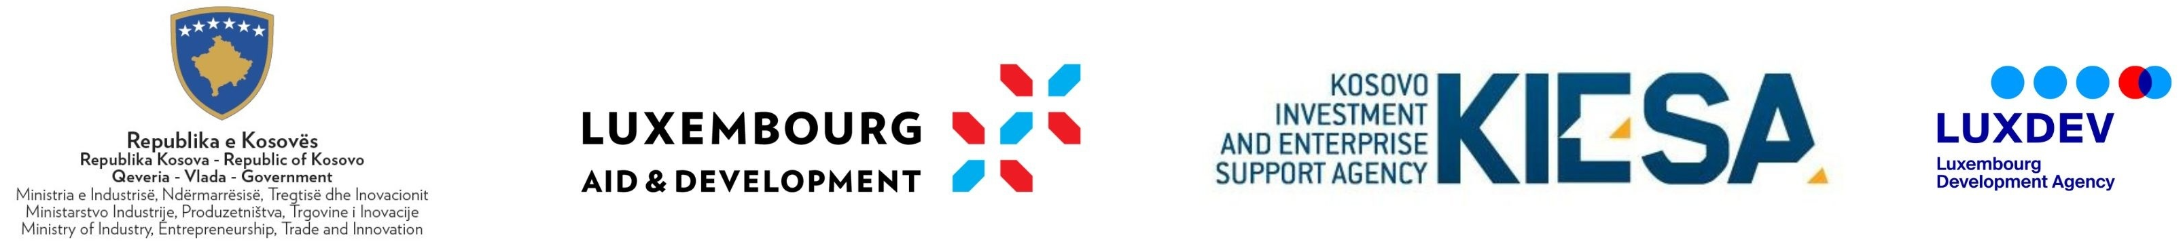

Statement of obligations

By signing this statement, I hereby confirm that all the information contained in this application is complete and accurate. If it is proven that I have submitted false or inaccurate information or data, including the criteria presented in the application file as an applicant to this grant scheme, I shall bear responsibility for the punitive consequences in accordance with the relevant applicable laws in Kosovo.
I fully aware that completing the application process does not guarantee the award of the grant requested from MIET/KIESA under this grant scheme.

- Have you fulfilled all obligations under AI 01/2018 from previous financial support, if you benefited from public funding sources from MIET during the past two years?

Please circle one:
  - Yes
  - No
  - I have not benefited previously and have no obligations

Additional comments, if any:

Personal contacts:

Full name:

(first name) (middle name) (last name))

Position:

Date:

Signature:

